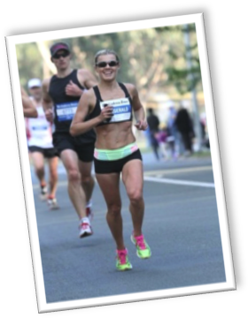
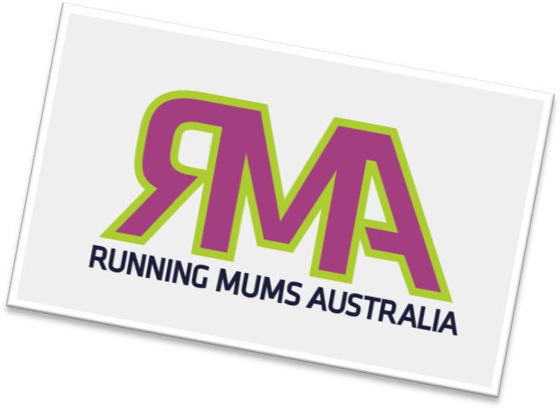
Anna is married and has two girls (aged 7 and 8). The entire family is active. Her girls are members of the North Suburbs Little Athletics Club, they swim, play soccer and basketball. Her husband has completed a couple of long course triathlons and has a history in basketball.
Anna studied law, humanities and financial services regulation at the tertiary and postgraduate level. She has worked for the boards of many of Australia’s top banks and financial institutions in law, compliance and in regulation, been a Senior Policy Analyst for the Australian Securities and Investments Commission and was selected to be included in the Women in Law Enforcement network.
When Anna is not doing something running related, she is writing (her other passion), reading, or spending time with family and friends. She has a keen interest in history, feminist literature and commentary, as well as health and nutrition for running women.
We are really excited to have Anna on board as a 2015 RMA ambassador. We believe that Anna is a great role model to those women who have started out running later in life, yet use their potential to reach their very best. We think Anna’s drive and commitment to her running, yet balancing that with her family is commendable and something that running mums can learn from. We can’t wait to see how Anna will continue to inspire the running women of Australia in 2015.

Anna Fitzgerald took up running in 2010 as part of a resolve to get fit and healthy. Although she ran a little as a kid, it was never something she enjoyed and therefore, it was with some reluctance that she participated in her first running event. It now fair to say that her passion for the sport has been ignited.
In the last four years she has run: over 10 half marathons; a multitude of 10km events; Athletics NSW Cross Country events as well as several City2Surfs in which she has placed in the top 25 females. She has represented NSW in the Australian Half Marathon Championships and won several Athletics NSW age group medals.
Anna is currently coached by Gary Howard of Run Crew but has run with many groups including HuRTS, SWEAT Sydney and her running club, the Sydney Striders. Her preferred events are the 10km and the Half Marathon however; she hopes to add the marathon to that list this year.

.

.

When Anna is not doing something running related, she is writing (her other passion), reading, or spending time with family and friends. She has a keen interest in history, feminist literature and commentary, as well as health and nutrition for running women.

We are really excited to have Anna on board as a 2015 RMA ambassador. We believe that Anna is a great role model to those women who have started out running later in life, yet use their potential to reach their very best. We think Anna’s drive and commitment to her running, yet balancing that with her family is commendable and something that running mums can learn from. We can’t wait to see how Anna will continue to inspire the running women of Australia in 2015.

RMA 2015 AMBASSADORS

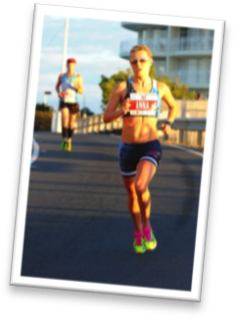
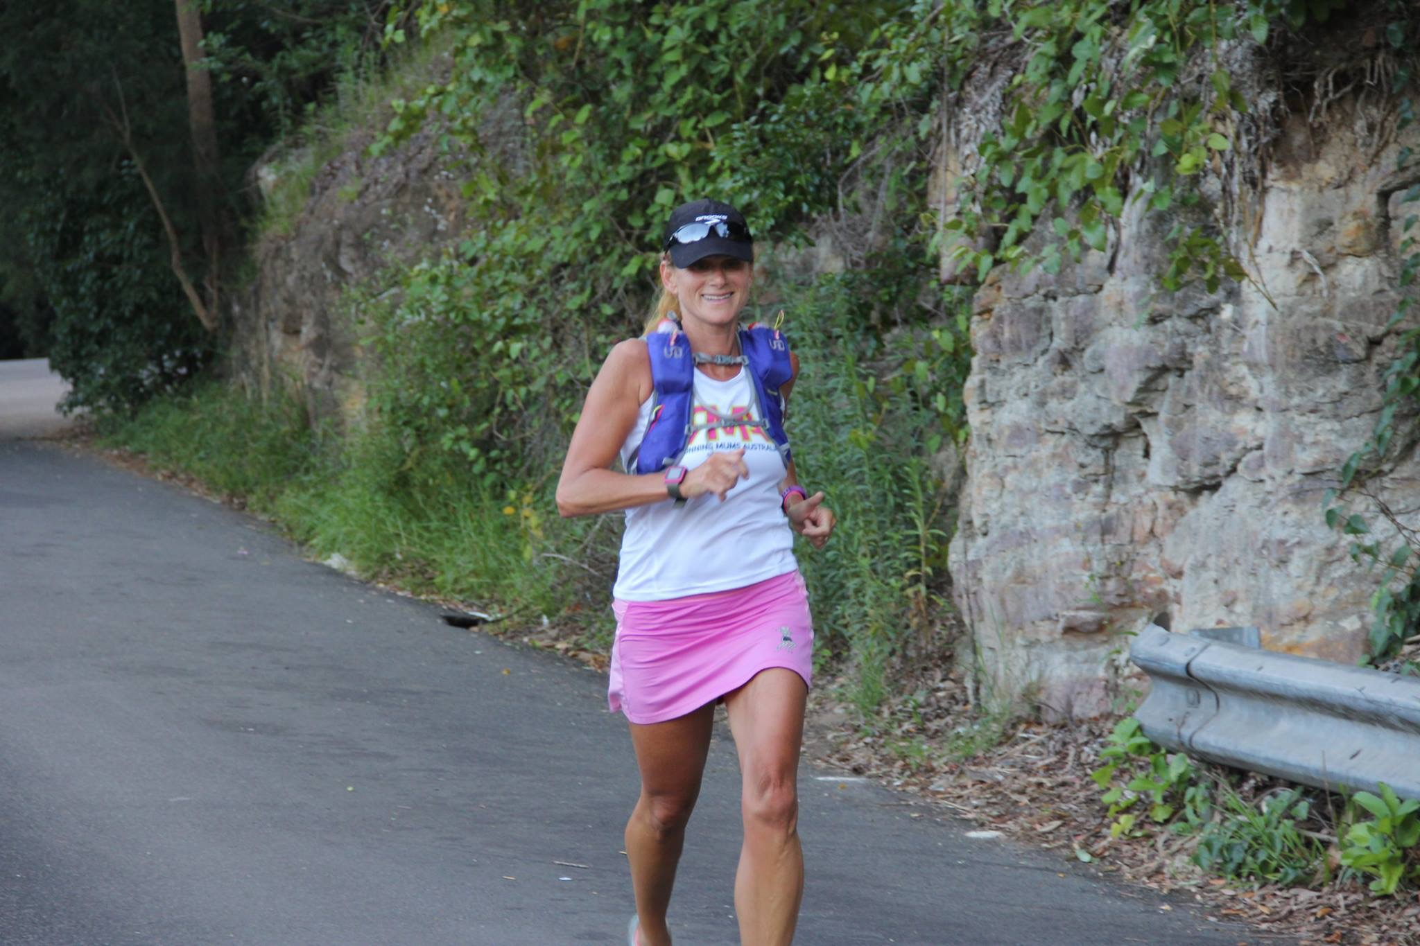
April Palmerlee began running when she moved to Sydney in 2003. After a few years of outdoor group personal training, she realized that running was the part of each session that she liked the best, so she left the personal trainer and joined SWEAT – a running group coached by Sean Williams.
She became active not only in competing but also in supporting runners all around Australia. She was NSW State Representative for the Australian Ultra Runners Association (AURA), Ambassador for the Comrades Ultra Marathon in South Africa, and she currently serves on the Executive Committee of the Sydney Striders, coordinating the Super Series. She has also founded and organized two running events: the Centennial Park Ultra 50/100 and the Southern Highlands Challenge 1/6/21/50km festival. She has completed about 50 marathons and ultra-marathons, plus hundreds of shorter races.
She is a mother of four active children (ages 3-13). They are all swimmers and runners.

Anna’s personal bests:
5km: 17:49mins,
10km: 36: 42mins,
City 2 Surf: 52: 59mins
Half Marathon: 79:46mins

Some of Anna’s other running achievements:
- 2nd in the Sydney Morning Herald Sun Run (2013)
- Selected as a NSW Representative in the Australian Half Marathon Championships.
- 11th in the Sun Herald City to Surf (2014)
- Age group champion in the NSW Short Course Cross Country Championships (2013)
- Winner or outright place-getter at a number of 10km events.

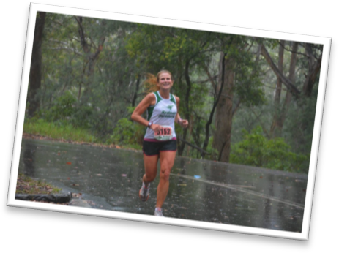
Her husband has also run many ultras and marathons. Every year April and her children participate together in many running events such as City 2 Surf. April’s passion has enriched the lives of her children, who are also talented athletes. She believes this is partly because they are learning the importance of dedication, determination and application to exercise at home, through seeing their parents get up every day and train, as well as being well taught at school and in their clubs.
In her spare time, she volunteers for: Centennial Park Community Consultative Committee, Fulbright Scholarship Committee, Sydney Striders Super Series, Six Foot Track Marathon Organizing Committee, and the Southern Highlands Challenge Running Festival. She also promotes women’s issues through giving speeches and leading discussion at the Australia-US Chamber of Commerce, various forums on International Women’s Day, and the Columbia University and Georgetown University Alumni Associations.
In the professional world, she has been a senior US diplomat, a fellow at two different think tanks, a magazine editor, a policy analyst in a financial institution, and an assistant to a fashion designer.
It is clear that April has a passion for running and strives to motivate and support women to participate in all her running endeavors. It is with her tremendous experience, dedication and relentless advocacy for women that we are thrilled to have April as a 2015 RMA ambassador to encourage, inspire and reach the running women of Australia.
Some of Aprils running achievements to date are listed below:
Winner Capital to Coast 2013 (ACT/NSW) 100km road and trail
Winner Stromlo Ultra 2013 (ACT) 6-Hour track
Winner Sri Chinmoy 2013 (QLD) 12-Hour track
Winner Bruny Island Ultra 2009 (TAS) 64km road
Winner Yurrebilla Trail Ultra 2009 (SA) 56km trail 2nd Place Carcoar Ultra 2013 (NSW) 60km road
2nd Place You Yangs 2010 (VIC) 80km trail
2nd Place Ross Marathon 2009 (TAS) 42.4km road
2nd Place Jabulani Challenge 2009 (NSW) 42.2km trail
3rd Place Glasshouse Ultra 2010 (QLD) 80km trail
4th Place Fitzroy Falls Trail Marathon 2009 (NSW) 42.2km trail

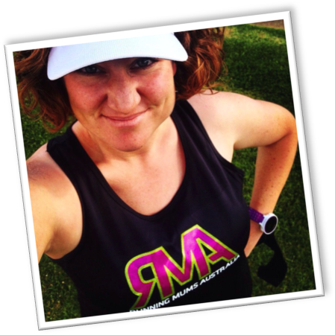
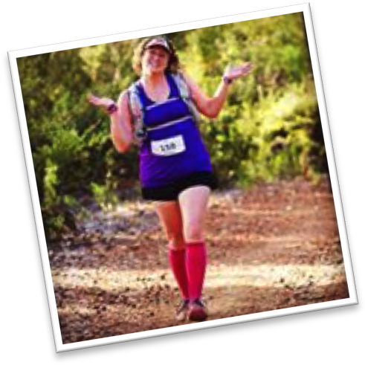
Emma Luscombe is a 32 year old single Mum to 5 gorgeous kids... 4 here earth and a baby girl in Heaven.
She lives on her own with her kids, a cat and a dog all squeezed into a tiny cottage, in a very small rural, coastal town called Bremer Bay (neighboring the Fitzgerald National Park) in the South East of Western Australia.
Besides running and looking after her kids she also work part time (or full time over summer!) at her local Resort (pub!) as an all-rounder doing everything from housekeeping to office and bar work.
Emma’s passions in life apart from running and her kids include writing, reading (mainly biographies), any type of crafts and spending time enjoying nature!
In May 2013 after battling with obesity and some very difficult family circumstances Emma finally started running, which in turn has transformed her life! She ran her first Half Marathon in August of 2013 and has since continued her running journey to run 4 Half Marathons, 2 Road Marathons & 2 Trail Ultras!
In 2015 Emma has some pretty amazing goals to tick off and aims to run 12 marathons (or ultras!) in 12 months, including 3 x 100K events, a 50 mile trail ultra and the Gold Coast Marathon! Emma is extremely excited about the year ahead and cannot wait to share her journey with you all!
As an ambassador for RMA the number one thing that Emma hopes to achieve is to help each and every one of you realise that ANYTHING is possible! There are no limitations or boundaries! Emma wants you to know that you ALL have so much strength and potential within you and that you are ALL amazing! She wants to show you that you can achieve all your goals and dreams, whilst juggling motherhood, especially as a single mum, because if she can do it then so can YOU!

Some of Emma’s running achievements are listed below:
2013:
Perth City to Surf Half Marathon
Fremantle Half Marathon
6 Inch Trail Marathon
2014:
Busselton Half Marathon
Perth HBF Run For A Reason 12K
Albany City to Surf 12K
Perth City to Surf Marathon
Fremantle Half Marathon
Busselton Marathon
6 inch Trail Marathon
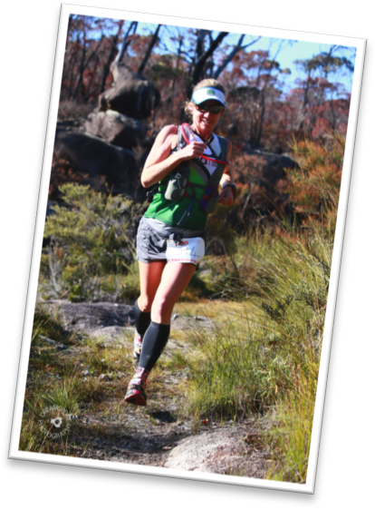

Jodie Oborne is Mother of Kira (16) and Cale (13) and wife to Tim , Jodie has a variety of interests. As a child she lived on a farm in regional Western Australia and vividly remembers helping with the sheep work and picking stumps and rocks and that harvest seemed to go on forever. At high school she learnt to play the flute and went to band camp. She has had a number of jobs working with the National Australia Bank in branches throughout Perth and in Albany and Gnowangerup and can drive a forklift.
During her 2nd pregnancy Jodie was diagnosed with Gestational Diabetes as a result of being overweight, despite being physically active. Jodie’s weight peaked at 82kg she now weighs around 57kg.
At the age of 32 Jodie decided to go back to school and commenced a Bachelor of Commerce Degree majoring in Economics at Curtin University which later lead to fulltime employment as a Policy Advisor at the Department of Treasury in Western Australia in 2009.
Throughout her life she played a number of sports socially including Basketball, Volleyball, Netball, Softball, Touch Rugby and Hockey. Jodie started to take her running seriously in 2008 when she ran her 1st marathon in 4:04:17 on the idyllic Rottnest Island. Three years later she took her running to another level participating in the Gold Coast Marathon with the aim of achieving a Boston Marathon Qualifier (BQ) and then participated in her 1st international event the Comrades Marathon in 2012. With some success over ultra distances she wondered just what she was capable of and set her sights on achieving selection for the 100km World Championships. In November 2014 this dream was realised at the 27th IAU 100km World Championships in Doha, Qatar.
In 2015 Jodie will represent Australia again at the 24 hour World Championships in Turin, Italy. Jodie has her sights set on the 200km and 24 hour age record and the Australian 48 hour record.
While dedicated to her training Jodie is happiest when running with a gang and misses her ‘C Team’ running mates in Western Australia she left behind when the family relocated to Brisbane in February 2013. She really misses the Saturday long runs in the Perth hills and the Sunday kinky runs and the yummy mummies. However through her running and as a member of River City Runners, Brisbane Trail Runners, Australian Ultra Runners Association and Athletics Queensland she has found a whole new gang of awesome Queensland runners, lives for Wednesday Morning Run Club, long runs in the Brisbane Forest Park and continues to enjoy life one run at a time.
We are really excited to have Jodie on board as a 2015 RMA ambassador. Jodie’s experience in the running world, her commitment and dedication to her training, her passion and desire to see women enter into ultra running, a down to earth attitude and community spirit make her a fantastic ambassador for Running Mums Australia.

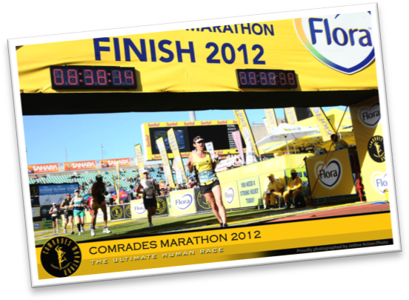
Jodie’s Recent Significant Achievements
2014 27th IAU 100km World Championships, Doha, Qatar
2014 1st Washpool World Heritage Trails, 50km (course record), NSW, Australia
2014 3rd Surf Coast Century (100km), Victoria, Australia
2014 Oxfam Trailwalker Sydney 2014 – 1st Female Team
2014 Oxfam Trailwalker Brisbane 2014 - 1st Team and female course record holder
2014 10th, The North Face 100km NSW, Australia.
2014 2nd Coburg 24 Hour (212.432km), Melbourne Australia.
2014 Australian Marathon Championships – Team Silver (Queensland)
Gold Coast Airport Marathon
2014 Australian Half-Marathon Championships – Team Gold (Queensland)
Blackmore’s Sydney Running Festival
2014 World Age Best Performance, 100 miles (track) 15:51:49 (to be ratified)
Australian Age Group Record;
Women’s 40-44 100 miles track, 15:51:49
Women’s 40-44 12 hours track, 127.789km
Women’s 40-44 50 miles road, 7:09:22

